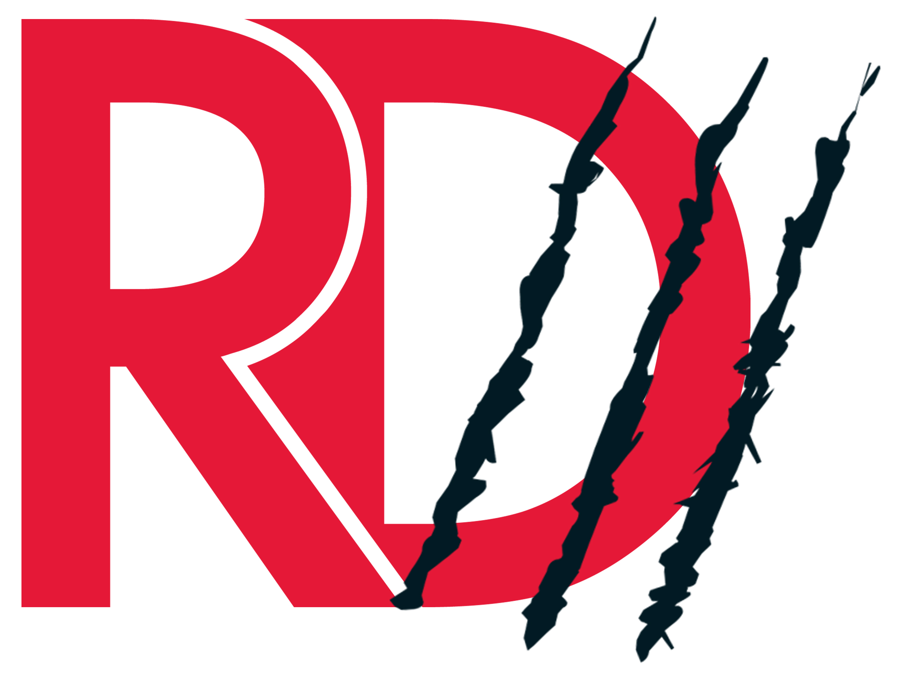
Sponsorship Information for the UH LGBT Alumni Association’s
Red Dinner III

Saturday, May 19th 2018

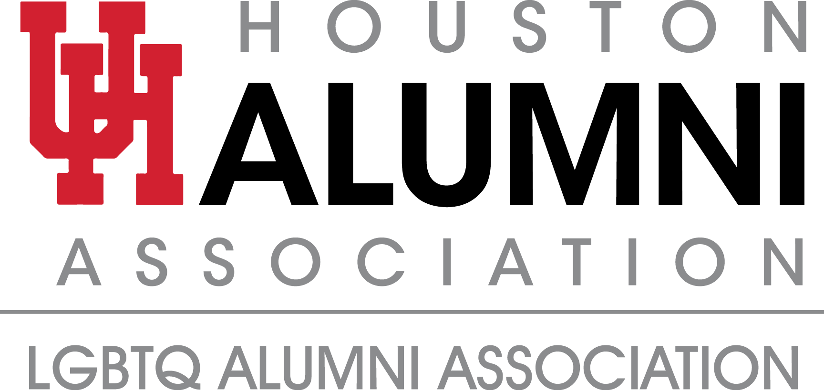
The Need Is Real.

Coming out as your authentic self is a journey for every person. For some it’s a moment of joy and celebration, but for too many UH students, there are unresolved questions and issues. What are the consequences? How will my friends and family react? What happens if I get cut off financially? Every year, students request funding from the University through the
UH LGBTQ Resource Center to help them offset the financial crisis brought on by coming out to their families. But funding for these students is desperately thin, and too many face the struggle of choosing between their education and homelessness.
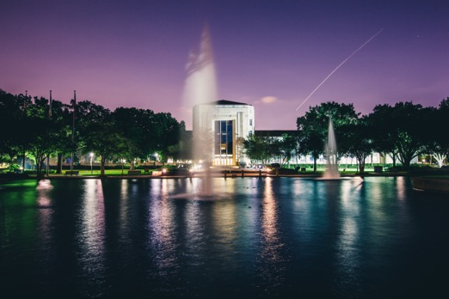
The University of Houston is recognized nationally as an inclusive, welcoming campus, and proudly diverse. The University has been a champion and ally for LGBTQ students. But the extraordinary financial and emotional circumstances many students face after they come out are too overwhelming for anyone to overcome. The UH LGBTQ Alumni Association is determined to offer those students financial resources through a crisis fund so no Cougar ever has to choose between their education and shelter or food or medications.

THAT IS A CHOICE NO COUGAR SHOULD EVER BE FORCED TO MAKE.

You Can Help.

Join us in providing financial solutions to UH students who are facing these impossible situations.
No one should lose their opportunity for an education because they come out as their true self.

Red Dinner is the annual fundraising gala for the University of Houston LGBTQ Alumni
Association benefiting UH students who have been financially affected as a result of their sexual identity or expression.

Last year at Red Dinner II, we successfully raised over $40,000! These funds help reduce the
economic impact to UH LGBTQ students whose families terminate financial support when they
“come out” as their authentic persons. Further, they allowed us to create an LGBTQIA+ scholarship program where we could empower students within the community based on academia and activism.

2018 Red Dinner Sponsorship Opportunities

Scarlet Sponsor $10,000
- Exclusive Presenting Sponsor for the 2018 UH Red Dinner III
- Premium Seating at Gala
- Expedient Check-In
- Branded Advertisement on the Red Dinner III Promotional Materials
- Brand or Logo with link on Red Dinner Website
- 10 VIP Tickets for Pre-Gala reception with Michael Sam
- Social Media Announcements of support
- Full-Page Advertisement in Program
- 10 VIP Tickets to After Party

Crimson Sponsorship $5,000
- Branded Advertisement with Red Dinner Campaign
- Brand or Logo with link on Red Dinner Website
- 10 VIP Tickets for Pre-Gala reception with Michael Sam
- Premium Table Placement at Gala
- Social Media Announcements of Support
- Full-Page Advertisement in the Program
- 10 VIP Tickets to After Party

Ruby Sponsorship $2,500
- Branded Advertisement with Red Dinner Campaign
- Brand or Logo with link on Red Dinner Website
- Preferred Table Placement at Gala for 10
- Social Media Announcement on support
- Half-page Advertisement in the program
- 10 General Admission Tickets to the After Party

Table Captain $1,500
- Preferred Table Placement for 10 at Red Dinner III
- Access for 2 to the VIP Reception to meet Michael Sam
- 10 General Admission Tickets to the After Party

Individual Underwriters $1,000
- Access for 2 to the VIP Reception to meet Michael Sam
- VIP Admission & Valet for Red Dinner III
- 2 General Admission Tickets to the After Party
- Named Recognition in Program and on the Red Dinner Website
- An Exclusive Cougar Gift (courtesy of the UH Alumni Association)

For more Information, please contact:
Stacey Peterson at SLPeterson837@gmail.com
Shawn Kuehn at Shawn.Kuehn@gmail.com
Joe Rera at jfrera@Central.UH.edu
Kevin Hamby at KevinHamby@aol.com

The University of Houston Alumni Association is a 501(c)(3) Non-Profit Organization.

